**A**

**MINOR PROJECT REPORT**

**On**

**Smart Doc: AI Powered Medical Consultant with Human Intellect to Support and Enhance People’s Lives in Emergencies**

Submitted in partial fulfillment of the requirement for the award of the degree of

**B.TECH**

**in**

**COMPUTER SCIENCE AND ENGINEERING**

**Submitted By**

**NAME OF THE STUDENT : Reg. No. RA1811003040117**

**

**DEPT. OF COMPUTER SCIENCE & ENGINEERING**

**SRM Institute of Science & Technology**

**Vadapalani Campus,Chennai**

**November 2021**

**A**

**MINOR PROJECT REPORT**

**On**

**Smart Doc: AI Powered Medical Consultant with Human Intellect to Support and Enhance People’s Lives in Emergencies**

Submitted in partial fulfillment of the requirement for the award of the degree of

**B.TECH**

**in**

**COMPUTER SCIENCE AND ENGINEERING**

**Submitted By**

**NAME OF THE STUDENT : Reg. No. RA1811003040117**



**DEPT. OF COMPUTER SCIENCE & ENGINEERING**

**SRM Institute of Science & Technology**

**Vadapalani Campus,Chennai**

**November 2021**



**BONAFIDE CERTIFICATE**

Certified that this project report **“Smart Doc: AI Powered Medical Consultant with Human Intellect to Support and Enhance People’s Lives in Emergencies”** is the bonafide work of “**M. Aishwarya”** who carried out the project work under my supervision.

|  |  |
| --- | --- |
| **SIGNATURE OF THE GUIDE** | **SIGNATURE OF THE HOD** |
|  |  |
| Name of the Staff with Qualification | Dr.S.Prasanna Devi, B.E.,M.E., Ph.D., PGDHRM.,PDF(IISc) |
| Assistant Professor | Professor |
| Department of Computer Science and Engineering | Department of Computer Science and Engineering |
| SRM Institute of Science & Technology | SRM Institute of Science & Technology |
| Vadapalani Campus | Vadapalani Campus |
|  |  |
|  |  |

**ACKNOWLEDGEMENT**

It is our privilege to express our sincerest regards to our project coordinator, **C.Sabarinathan**  for his valuable inputs, able guidance,encouragement,whole-hearted cooperation and constructive criticism throughout the duration of our project.

We deeply express our sincere thanks to our Head of Department Dr .S.Prasanna Devi, for encouraging and allowing us to present the project on the topic “Smart Doc: AI Powered Medical Consultant with Human Intellect to Support and Enhance People’s Lives in Emergencies “ at our department premises for the partial fulfillment of the requirements leading to the award of B-Tech degree.

We take this opportunity to thank all our faculty members, Dean, Dr.C.V.Jayakumar, and Management who have directly or indirectly helped our project. Last but not the least we express our thanks to our friends for their cooperation and support.

**TABLE OF CONTENTS**

**List of Figures 1**

**Abstract 2**

1. **Introduction** 
   1. **Overview 3**
   2. **Problem Definition 3**
   3. **Existing System 4**
   4. **Proposed System 4**
2. **Project Work**
   1. **Requirements** 
      1. **Hardware 5**
      2. **Software 5**
      3. **Tools and Technologies 5**
   2. **Modules** 
      1. **Data Gathering 6**
      2. **Data Cleaning 6**
      3. **Model Building 6**
      4. **Web Development 6**
      5. **Integration 7**
   3. **System Architecture 7**
   4. **Diagrams 8**
   5. **Algorithms** 
      1. **Support Vector Classifier 9**
      2. **Random Forest Classifier 10**
      3. **Gaussian Naive Bayes Classifier 11**
3. **Implementation** 
   1. **Source Code 13**
   2. **Output 35**
4. **Conclusion** 
   1. **Conclusion 39**
   2. **Future Scope 39**
5. **Reference 40**
6. **Udemy Course Certification 42**

**LIST OF FIGURES**

**Fig 2.1 Architecture Diagram 7**

**Fig 2.2 Use Case Diagram 8**

**Fig 2.3 Class Diagram 8**

**Fig 2.4 Data Flow Diagram 9**

**Fig 2.5 Object Diagram 9**

**Fig 2.6 Support Vector Classifier 10**

**Fig 2.7 Random Forest Classifier 11**

**Fig 2.8 Naïve Bayes Theorem 11**

**Fig 2.9 Gaussian Naïve Bayes Classifier 12**

**Fig 2.10 Illustration of how Gaussian Naïve Bayes Classifier 12**

**works on each data point**

**Fig 3.1 Smart Doc 33**

**Fig 3.2 Mic Access 34**

**Fig 3.3 Getting User Details 34**

**Fig 3.4 User Table 35**

**Fig 3.5 Disease Prediction and Treatment 35**

**Fig 3.6 Schedule Appointment 36**

1

**ABSTRACT**

Tech-based self-service channels and digital health interventions have the potential to support the patients in their everyday life and health professionals likewise. The rise in artificial intelligence and innovation in digital technologies have paved the way for the medical systems to expand to meet the expectations of the people who need health care support especially during these kinds of unprecedented circumstances such as hay fever, flu, and other viral infections. Although there are scalable self-service channels such as Alexa, Google Assistant, Siri, yet they cannot be applied in medical care settings due to their lack of domain knowledge. Hence this project presents a healthcare chatbot called ‘Smart Doc’ created using Artificial Intelligence that can have a significant impact on the lives of people. This chatbot provides us with a human-system interaction with a user-friendly interface and it aims to solve the specific prerequisites of a person who needs healthcare suggestions before visiting the hospital. The chatbot system works on the inputs provided by the user (patient) and answers them accordingly. The functionalities of Smart Doc include primary healthcare services where a normal person with a mobile can be able to have interaction regarding the services. The chatbot enables the person to identify themselves by providing their age and contact number and then allows them to specify their symptoms. It also helps to schedule an appointment with the concerned doctor in a nearby hospital facility or to have an online discussion with the doctor regarding the treatment. This will reduce healthcare costs and improve accessibility to medical knowledge even for people living in rural areas while enhancing their lives at the same time.

2

**CHAPTER- 1**

**INTRODUCTION**

* 1. **OVERVIEW**

Artificial Intelligence is undoubtedly impacting the healthcare industry as the utilization of chatbots has become popular recently. Organizations are reaping benefits of these AI-enabled virtual agents for automating their routine procedures and provide clients the 24×7 attention in areas like payments, client service, and marketing. AI has come as a savior in the healthcare industry. From detecting diseases to using life-saving machines, AI is making strong new scopes across the industry. Common people are not medically trained for understanding the extremity of their diseases. This is where chatbots can be a great help. They gather prime data from patients and depending on the input, they give more data to patients regarding their conditions and recommend further steps also.

* 1. **PROBLEM DEFINITION**

To lead a better life healthcare is extremely much important. But it's very difficult to get the consultation with the doctor just in case of any health issues. The

user can achieve the real advantage of a chatbot only if it can diagnose all quite disease and supply necessary information. A text-to-text diagnosis bot engages patients in conversation about their medical issues and provides a personalized

diagnosis supported their symptoms. Hence, people will have a thought about their health and have the correct protection.

3

* 1. **EXISTING SYSTEM**

Safe drug Bot is a virtual assistant designed to help healthcare professionals in providing valuable guidance and monitoring.Babylon Health offers A.I. consultation based on personal medical history and common medical knowledge as well as live video consultation with a real doctor.Your .Md is a symptom checker  free platform offers actionable health information based on highly accurate sources and lets the user make the best choices for his health.Ada Health can assess the user’s health based on the indicated symptoms using its vast, A.I.-based database.Buoy Health chatbot thoroughly asks you about the details of your medical state and offers you various solutions and actionable steps to take.

* 1. **PROPOSED SYSTEM**

The Proposed System consists of a user friendly chat interface through which a user can communicate with the system. It focuses on a healthcare chatbot which analyses the user’s symptoms through a conversation with the user. The Smart Doc can converse with the user via text or speech. The symptoms are then passed to a Machine Learning (ML) algorithm that has been trained to diagnose diseases based on symptoms. The chatbot can make a predictive diagnosis. This can assist in providing the initial response as well as guide the individual to a specialized healthcare professional. The project is developed for the user to save the user their time in consulting the doctors or experts for the healthcare solution. Here, the application is developed to provide quality of answers in a short period of time. The application is improved with the security and effectiveness upgrades by ensuring user protection and characters and retrieving answers consequently for the questions. It removes the burden from the answer provider by directly delivering the answer to the user using an expert system.

4

**CHAPTER- 2**

**PROJECT WORK**

* 1. **REQUIREMENTS**

The project was implemented using the following hardware and software requirements.

* + 1. **HARDWARE**
* Processor-i3 Processor Based Computer or higher
* Memory: 1 GB
* Hard Disk: 50 GB
  + 1. **SOFTWARE**
* Windows 7 or higher
* Google Chrome Browser
* Visual Studio Code
* My SQL
  + 1. **TOOLS AND TECHNOLOGIES**
* Python
* Flask
* HTML5
* CSS5
* MySQL
* Javascript

5

* 1. **MODULES**
     1. **Data Gathering**

Data preparation is the primary step for any machine learning problem. The dataset from Kaggle is used for the project. This dataset consists of a CSV file which will be used to train the model. There is a total of 133 columns in the dataset out of which 132 columns represent the symptoms and the last column is the prognosis.

* + 1. **Data Cleaning**

Cleaning is the most important step in a machine learning project. The quality of the data determines the quality of a machine learning model. So it is always necessary to clean the data before feeding it to the model for training. In the dataset all the columns are numerical, the target column i.e. prognosis is a string type and is encoded to numerical form using a label encoder.

* + 1. **Model Building**

After gathering and cleaning the data, the data is ready and can be used to train a machine learning model. The cleaned data is used to train the Support Vector Classifier, Naive Bayes Classifier, and Random Forest Classifier. After training the three models, The diseases is predicted for the input symptoms by combining the predictions of all three models. This makes the overall prediction more robust and accurate.

* + 1. **Web Development**

The Front end of the project is created using HTML and CSS. It includes a user-friendly chat interface in which the user can communicate with the bot via text or over voice. Its functioning is achieved using Javascript. When a user clicks or performs any action a javascript function is called depending on the id of the element on which the action was performed. It also uses jquery to get the input from the user and reply through the flask framework.

6

* + 1. **Integration**

Flask is an important web framework in python which is used to create end-to-end projects. It is based on the jinja2 template engine which combines web templates along with a data source. The final aim is to render dynamic pages. This project is developed using the flask that integrates the python modules with the web page. It also connects to the MySQL database where the data collected from the user is stored.

* 1. **SYSTEM ARCHITECTURE**

The Figure (2.1) below represents the user interaction with the Smart Doc. The user’s details will be collected and stored in the database for future references. The smart doc then identifies the symptoms from the user’s input and analyzes it after which the system displays the disease based on the user symptoms and suggests the required treatment.

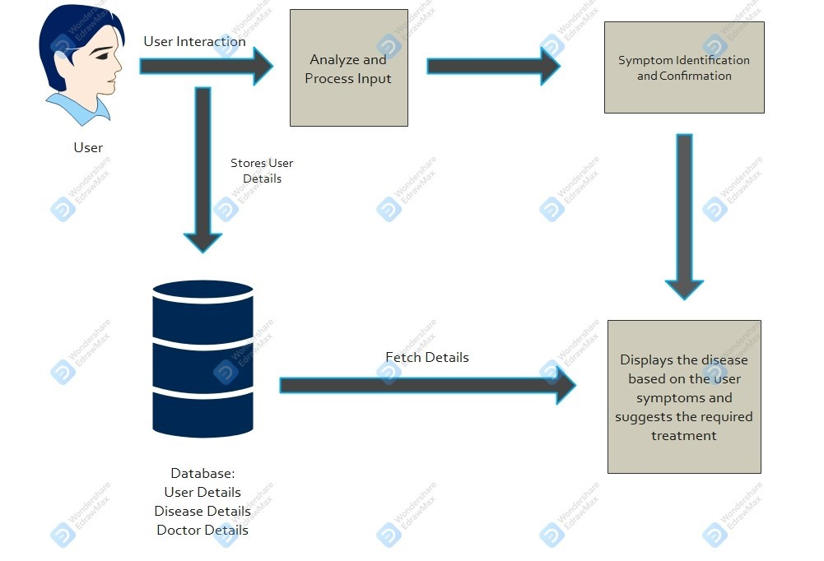

Fig 2.1 Architechture Diagram

7

* 1. **DIAGRAMS**

**Use Case Diagram:**

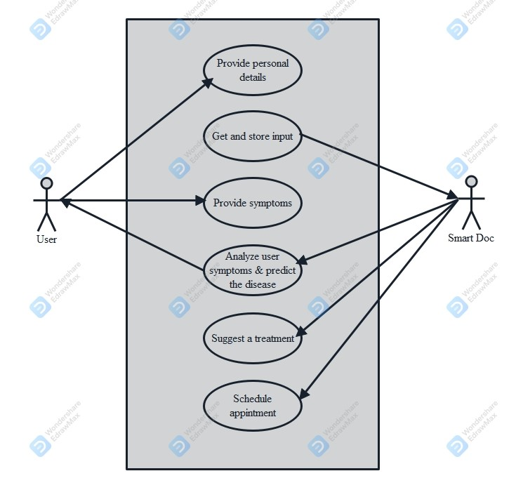

Fig 2.2 Use Diagram

**Class Diagram:**

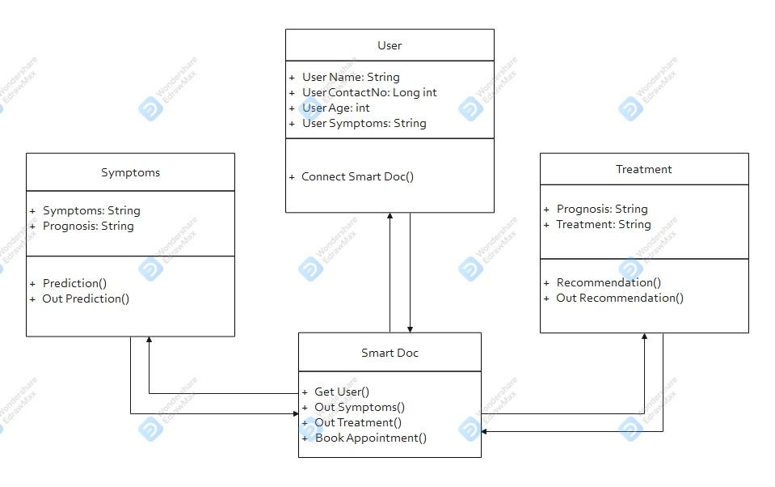

Fig 2.3 Class Diagram

8

**Data Flow Diagram:**

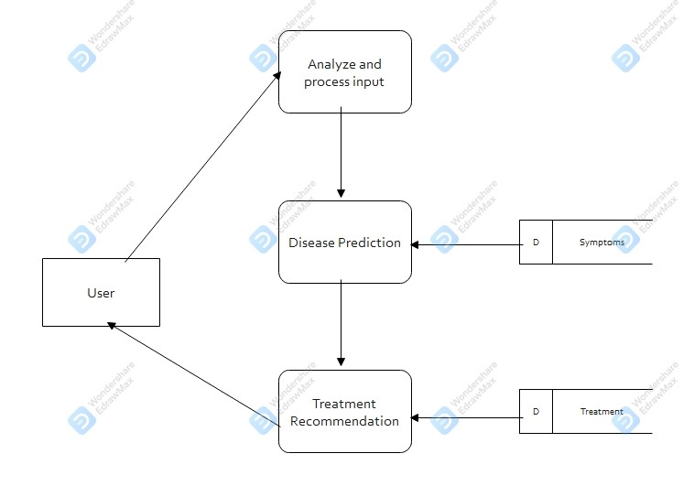

Fig 2.4 Data Flow Diagram

**Object Diagram:**

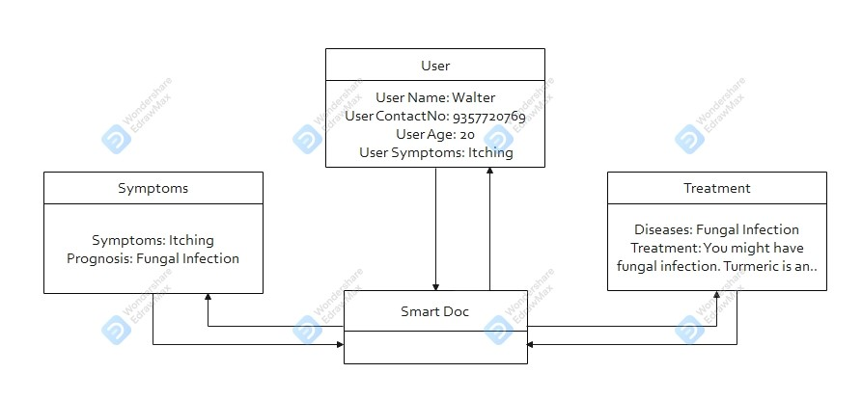

Fig 2.5 Object Diagram

**2.5 ALGORITHMS**

**2.4.1 Support Vector Classifier:**

Support Vector Classifier is a discriminative classifier i.e. when given a labeled training data, the algorithm tries to find an optimal hyperplane that accurately separates the samples into different categories in hyperspace.

9

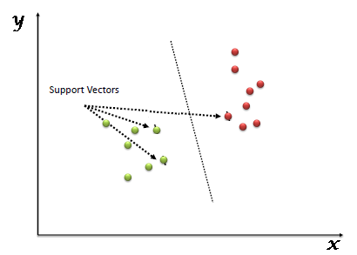

Fig 2.6 Support Vector Classifier

**2.4.2 Random Forest Classifier:**

Random Forest is an ensemble learning-based supervised machine learning classification algorithm that internally uses multiple decision trees to make the classification. In a random forest classifier, all the internal decision trees are weak learners, the outputs of these weak decision trees are combined i.e. mode of all the predictions is as the final prediction.

10

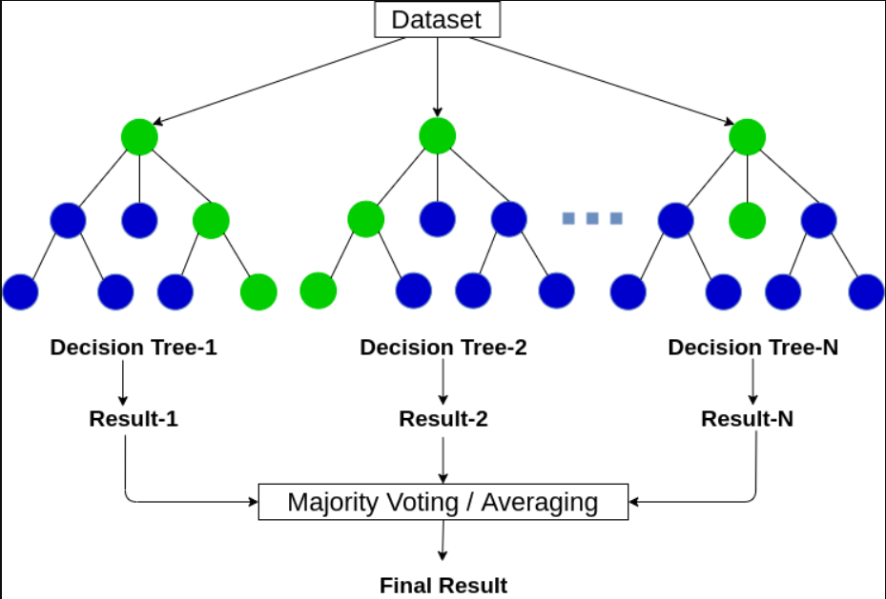

Fig 2.7 Random Forest Classifier

**2.4.3 Gaussian Naïve Bayes Classifier:**

It is a probabilistic machine learning algorithm that internally uses Bayes Theorem to classify the data points. In simple terms, a Naive Bayes classifier assumes that the presence of a particular feature in a class is unrelated to the presence of any other feature.

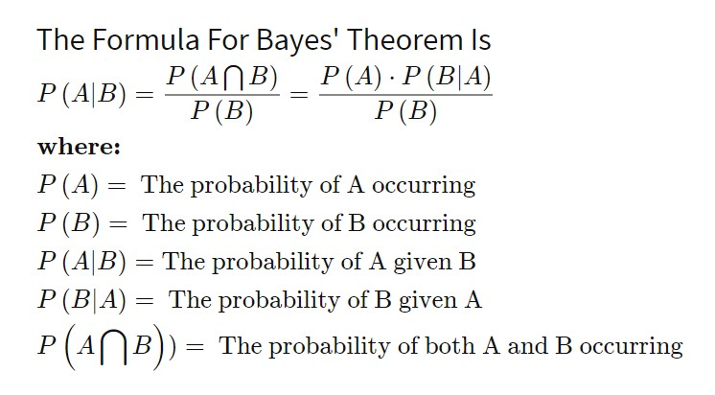

Fig 2.8 Naïve Bayes Theorem

11

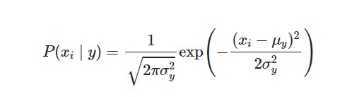

Fig 2.9 Gaussian Naïve Bayes Classifier

Sometimes assume variance

* is independent of Y (i.e., σi),
* or independent of Xi (i.e., σk)
* or both (i.e., σ)

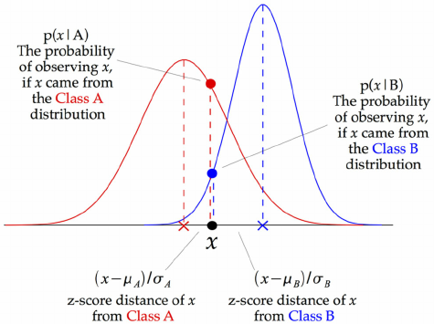

Fig 2.10 Illustration of how Gaussian Naïve Bayes Classifier works for each data point

The above illustration indicates how a Gaussian Naive Bayes (GNB) classifier works. At every data point, the z-score distance between that point and each class-mean is calculated, namely the distance from the class mean divided by the standard deviation of that class. Thus, we see that the Gaussian Naive Bayes has a slightly different approach and can be used efficiently.

12

**CHAPTER- 3**

**IMPLEMENTATION**

* 1. **SOURCE CODE**

**HTML:**

# Importing the required modules

from flask import Flask, url_for, render_template, request

from predict import predictDisease

from response import check_all_messages

from flask_mysqldb import MySQL

import yaml

# Creating the Flask app

app=Flask(__name__)

# Configure db

db= yaml.safe_load(open('db.yaml'))

app.config['MYSQL_HOST']= db['mysql_host']

app.config['MYSQL_USER']= db['mysql_user']

app.config['MYSQL_PASSWORD']= db['mysql_password']

app.config['MYSQL_DB']= db['mysql_db']

mysql= MySQL(app)

# Creating the route

@app.route('/')

13

# Function to return the required template

def home():

    return render_template('index.html')

is_name = False

is_age = False

is_contact= False

Name=""

Age=""

ContactNumber=""

#Creating the route to communicate with the user

@app.route('/get')

def reply():

    userText=request.args.get('msg')

    global is_name

    global is_age

    global is_contact

    global Name

    global Age

    global ContactNumber

    if(is_name == False):

        Name=userText

        is_name = True

        return "Could you please mention your age?"

    elif(is_age == False):

        Age=userText

        is_age = True

        return "Please Provide your contact number."

14

 elif(is_contact == False):

        ContactNumber=userText

        is_contact = True

        # Connecting to MySQL and Inserting user details

        cur=mysql.connection.cursor()

        cur.execute("INSERT INTO users(UserName,Age,ContactNumber) VALUES(%s, %s, %s)",(Name,Age,ContactNumber))

        mysql.connection.commit()

        cur.close()

        return "Thank you for providing the details. How may I help you?"

    return str(check_all_messages(userText))

if __name__=='__main__':

    app.run(debug=True)

**CSS:**

* {

    margin: 0;

    padding: 0;

    box-sizing: border-box;

}

/*main div*/

.main {

    width: 100vw;

    height: 100vh;

    display: flex;

    justify-content: center;

    align-items: center;

    background-image: linear-gradient(rgb(44, 50, 93), rgb(30, 31, 53));

}

15

/*Mic Action*/

.microphoneAction {

    color: aliceblue;

    height: 5vh;

    background-color: rgb(40, 41, 63);

    border-radius: 5px;

    display: flex;

    justify-content: center;

    align-items: center;

    text-align: center;

    position: absolute;

    z-index: 20;

    width: 20vw;

    bottom: 4vh;

    display: none;

}

/*stop*/

.stop {

    display: flex;

    justify-content: center;

    align-items: center;

    position: absolute;

    bottom: 4.2vh;

    left: 57.5vw;

    cursor: pointer;

    z-index: 20;

    opacity: 0.7;

    display: none;

}

16

/*sub div*/

.sub {

    width: 70vw;

    height: 80vh;

    border-radius: 10px;

    background-color: rgb(5, 12, 50);

    position: absolute;

    overflow-y: auto;

    padding-bottom: 200px;

    overflow-wrap: break-word;

}

/*input tag*/

.chat {

    width: 70vw;

    z-index: 100000;

    position: absolute;

    bottom: 9.4vh;

}

/*mic*/

#talk {

    position: absolute;

    width: 1.9vw;

    height: 5.5vh;

    cursor: pointer;

    opacity: 0.7;

    background-color: rgb(44, 50, 93);

    border-radius: 0px 0px 10px 0px;

}

17

/*textbox*/

#send {

    width: 68.1vw;

    height: 5.5vh;

    overflow-y: auto;

    background-color: rgb(44, 50, 93);

    opacity: 0.7;

    border-radius: 0px 0px 0px 10px;

    font-size: 1.2rem;

    outline: none;

    border: none;

    color: rgb(240, 248, 255);

    resize: none;

}

/*message*/

.msg {

    width: 34vw;

    height: auto;

    background-image: linear-gradient(rgb(255, 157, 157), rgb(128, 79, 79));

    opacity: 0.5;

    color: rgb(5, 12, 30);

    margin-top: 2vh;

    padding: 7px;

    border-radius: 12px;

}

/*bot message*/

.msg.bot {

    margin-left: 2vw;

    float: left;

}

/*user message*/

.msg.user {

    margin-right: 2vw;

    float: right;

}

18

**Javascript:**

var number = 0;

//Function that replies back

function botAns(userInput) {

    //split the input into an array of strings whenever a blank space is encountered

    const arr = userInput.split(" ");

    //loop through each element of the array and capitalize the first letter

    for (var i = 0; i < arr.length; i++) {

        arr[i] = arr[i].charAt(0).toUpperCase() + arr[i].slice(1);

    }

    //Join all the elements of the array back into a string using a blankspace as a separator

    const modInput = arr.join(" ");

    //div element which holds the input

    var user = document.createElement('div');

    var bot = document.createElement('div');

    //Assigning the class

    user.className = 'msg user';

    bot.className = 'msg bot';

    //TextNode to display the input given by user

    var userEntry = document.createTextNode(userInput);

    document.getElementById('sub').appendChild(user);

    let x = document.getElementsByClassName('user');

    x[number].appendChild(userEntry);

    number += 1;

19

//Passing the input entered by user to Flask app

    $.get('/get', { msg: modInput }).done(function(data) {

        //TextNode to display the reply given by bot

        readOutLoud(data);

        botRpl = document.createTextNode(data);

        document.getElementById('sub').appendChild(bot);

        let y = document.getElementsByClassName('bot');

        y[number].appendChild(botRpl);

        //Clearing the textbox after sending the message

        document.getElementById('send').value = '';

    })

}

//Function that reads out loud

function readOutLoud(speak) {

    let speech = new SpeechSynthesisUtterance();

    speech.lang = "en-US";

    speech.text = speak;

    speech.volume = 1;

    speech.rate = 1;

    speech.pitch = 1;

    window.speechSynthesis.speak(speech);

}

20

//Function that Gets the input given by user

function myKeypress(e) {

    if (window.event) {

        if (e.keyCode == 13) {

            //Auto Scroll

            $('#sub').scrollTop($('#sub').scrollTop() + 100);

            var entry = document.getElementById('send').value;

            //Passing the data given by user to a function that will reply back

            botAns(entry)

        }

    }

}

//Making the microphone work

function myClick(e) {

    document.getElementById('microphoneAction').style.display = 'flex';

    document.getElementById('stop').style.display = 'flex';

    //Speech recognition object

    var SpeechRecognition = SpeechRecognition || webkitSpeechRecognition;

    var recognition = new SpeechRecognition();

    //Runs when the speech recognition starts

    recognition.onstart = function() {

        document.getElementById('microphoneAction').innerHTML = "Listening..Please Speak!";

    };

21

//Runs When user is done speaking

    recognition.onspeechend = function() {

        recognition.stop();

        document.getElementById('microphoneAction').style.display = 'none';

        document.getElementById('stop').style.display = 'none';

    }

    //Runs when the speech recognition returns result

    recognition.onresult = function(event) {

        var userMicrophone = event.results[0][0].transcript;

        //Getting the ans from the bot

        botAns(userMicrophone);

    };

    // Start recognition

    recognition.start();

    //Stop recognition

    document.getElementById('stop').addEventListener('click', (e) => {

        recognition.stop();

        document.getElementById('microphoneAction').style.display = 'none';

        document.getElementById('stop').style.display = 'none';

    });

}

22

**Python- Response:**

# Importing libraries

import re

import random

from predict import predictDisease

# Function to check the probability of the message

def message_probability(user_message, recognised_words, single_response=False, required_words=[]):

    message_certainty = 0

    has_required_words = True

    # Counts how many words are present in each predefined message

    for word in user_message:

        if word in recognised_words:

            message_certainty += 1

    # Calculates the percent of recognised words in a user message

    percentage = float(message_certainty) / float(len(recognised_words))

    # Checks that the required words are in the string

    for word in required_words:

        if word not in user_message:

            has_required_words = False

            break

    # Must either have the required words, or be a single response

    if has_required_words or single_response:

        return int(percentage * 100)

    else:

        return 0

23

# Function to return the answer based on user input

def check_all_messages(user_input):

    message = re.split(r'\s+|[,;?!.-]\s*', user_input.lower())

    highest_prob_list = {}

    # Simplifies response creation / adds it to the dict

    def response(bot_response, list_of_words, single_response=False, required_words=[]):

        nonlocal highest_prob_list

        highest_prob_list[bot_response] = message_probability(message, list_of_words, single_response, required_words)

    # Responses -------------------------------------------------------------------------------------------------------

    response(hello(),['hello','hi','hey','hai','smart','doc','hei','hay'], single_response=True)

    response(greetings(),['morning','mrng','afternoon','noon','nun','evening','eve','greetings'],single_response=True)

    response(bye(),['bye','goodbye','bubye','tata'], single_response=True)

    response(help(),['please','help','pls'], single_response=True)

    response(how(),['how','are','you','doing'], required_words=['how'])

    response(good(),['fine','good','great','better','awesome','nice'], single_response=True)

    response(thanks(),['thank','thanks'], single_response=True)

    response(yeah(),['yeah','sure','yes','definitely','yup', 'ok','okie'], single_response=True)

    response(pain(),['i','have','got','not','feeling','paining','sick','tired'], single_response=True)

    response(book_appointment(),['book','appointment', 'doctor','schedule'],single_response=True)

24

# Functions to respond back------------------------------------------------------

def hello():

    hello=['Hi, How can I help you today?',

            'Hello there, How can I be of service?',

            'Hi, How can I help you?',

            'Hello, How can I help?',

            'Hey, How can I help?',

            'Hi. It\'s good to hear from you. How can I help?'

          ][

    random.randrange(6)]

    return hello

def greetings():

    greetings=['Greetings of the day! How are you doing?',

               'Nice to see you!',

               'Greetings of the day!',

               'Hi. It\'s good to hear from you. How can I help?',

               'Have a great day!',

               'Hey, How can I help?'

              ][

    random.randrange(6)]

    return greetings

def bye():

    bye=['Take care, See you!',

         'Have a nice day!',

         'Take care, bye!',

         'bye',

         'ta-ta',

         'goodbye'

        ][

    random.randrange(6)]

    return bye

25

def help():

    help=['I\'m here to help you.',

          'I\'ll do my best.',

          'I\'ll do all I can.',

          'I\'m glad to help you.',

          'I\'m here to listen.',

          'I would love to help you.'

         ][

    random.randrange(6)]

    return help

def how():

    how=['I\'m doing fine, and you?',

         'I\'m fine. You\'re very kind to ask, especially in these tempestous times.',

         'I\'m splendid, Thank you for asking.',

         'Great, thanks. What can I do for you?',

         'I\'m great. Thank you for asking.',

         'Awesome! What about you?'

        ][

    random.randrange(6)]

    return how

def good():

    good=['It\'s awesome being able to help.',

          'Great!',

          'It\'s good to hear.',

          'Cool.',

          'Cool, Is there anything else I can do?',

          'I\'m happy you\'re happy.'

         ][

    random.randrange(6)]

    return good

26

def thanks():

    thanks=['You\'re very welcome!',

            'I\'m honoured to serve.',

            'No worries, I\'m here to help.',

            'I\'m here to help.',

            'You\'re the best, I love helping you.',

            'Just doing my job.'

           ][

    random.randrange(6)]

    return thanks

def yeah():

    yeah=['Okie..',

          'Nice',

          'Ok',

          'Okay',

          'Cool',

          'Right!'

        ][

    random.randrange(6)]

    return yeah

def pain():

    pain=['That does not sound good. Could you please mention your symptoms?',

          'I\'m sorry to hear that. Could you please mention your symptoms?',

          'Could you please mention your symptoms?',

          'I\'m sorry. Could you please mention your symptoms?',

          'I can understand. Could you please mention your symptoms?',

          'Okie, I get it. Could you please mention your symptoms?'

        ][

    random.randrange(6)]

    return pain

27

def book_appointment():

    website="https://www.apollo247.com/specialties"

    return "Please go to this link to book an appointment: "+website

def symptoms(rawData):

    ans=predictDisease(rawData)

    return ans

**Python- Prediction:**

# Importing libraries

import numpy as np

import pandas as pd

from scipy.stats import mode

from sklearn.preprocessing import LabelEncoder

from sklearn.model_selection import train_test_split

from sklearn.metrics import accuracy_score

from sklearn.svm import SVC

from sklearn.naive_bayes import GaussianNB

from sklearn.ensemble import RandomForestClassifier

import random

# Reading the training data

data_path="Diseases.csv"

data=pd.read_csv(data_path)

# Encoding the target value (prognosis column) into numerical value using LabelEncoder

encoder = LabelEncoder()

data["prognosis"] = encoder.fit_transform(data["prognosis"])

28

# Training the models

X = data.iloc[:,:-1]

Y= data.iloc[:, -1]

X_train, X_test, y_train, y_test =train_test_split(X, Y, test_size = 0.2, random_state = 24)

# print(f"Train: {X_train.shape}, {y_train.shape}")

# print(f"Test: {X_test.shape}, {y_test.shape}")

# Training and testing SVM Classifier

svm_model = SVC()

svm_model.fit(X_train, y_train)

preds = svm_model.predict(X_test)

# print(f"Accuracy on train data by SVM Classifier: {accuracy_score(y_train, svm_model.predict(X_train))*100}")

# print(f"Accuracy on test data by SVM Classifier: {accuracy_score(y_test, preds)*100}")

# Training and testing Naive Bayes Classifier

nb_model = GaussianNB()

nb_model.fit(X_train, y_train)

preds = nb_model.predict(X_test)

# print(f"Accuracy on train data by Naive Bayes Classifier: {accuracy_score(y_train, nb_model.predict(X_train))*100}")

# print(f"Accuracy on test data by Naive Bayes Classifier: {accuracy_score(y_test, preds)*100}")

# Training and testing Random Forest Classifier

rf_model = RandomForestClassifier(random_state=18)

rf_model.fit(X_train, y_train)

preds = rf_model.predict(X_test)

# print(f"Accuracy on train data by Random Forest Classifier: {accuracy_score(y_train, rf_model.predict(X_train))*100}")

# print(f"Accuracy on test data by Random Forest Classifier: {accuracy_score(y_test, preds)*100}")

29

# Training the models on whole data

final_svm_model = SVC()

final_nb_model = GaussianNB()

final_rf_model = RandomForestClassifier(random_state=18)

final_svm_model.fit(X, Y)

final_nb_model.fit(X, Y)

final_rf_model.fit(X, Y)

symptoms = X.columns.values

# Creating a symptom index dictionary to encode the input symptoms into numerical form

symptom_index = {}

for index, value in enumerate(symptoms):

symptom = " ".join([i.capitalize() for i in value.split("_")])

symptom_index[symptom] = index

data_dict = {

"symptom_index":symptom_index,

"predictions_classes":encoder.classes_

}

# Defining the Function Input: string containing symptoms separated by commmas Output: Generated predictions by models

def predictDisease(symptoms):

    symptoms = symptoms.split(", ")

30

# creating input data for the models

    input_data = [0] * len(data_dict["symptom_index"])

    try:

        for symptom in symptoms:

            index = data_dict["symptom_index"][symptom]

            input_data[index] = 1

        # reshaping the input data and converting it

        # into suitable format for model predictions

        input_data = np.array(input_data).reshape(1,-1)

        # generating individual outputs

        rf_prediction = data_dict["predictions_classes"][final_rf_model.predict(input_data)[0]]

        nb_prediction = data_dict["predictions_classes"][final_nb_model.predict(input_data)[0]]

        svm_prediction = data_dict["predictions_classes"][final_svm_model.predict(input_data)[0]]

        # making final prediction by taking mode of all predictions

        final_prediction = mode([rf_prediction, nb_prediction, svm_prediction])[0][0]

        remedy=cure(final_prediction)

        return "You might have "+final_prediction+ ". "+remedy

31

except KeyError:

        rpl=["Could you please re-phrase that? ",

            "I’m sorry, I don’t understand.",

            "Sorry, I didn’t get that.",

            "I can’t make head nor tail of what you’re saying.",

            "What does that mean?",

            "Can you try saying that again in a different way? I don't understand.",

            ][

        random.randrange(6)]

        return rpl

# Function to return an approriate treatment for the predicted disease

def cure(remedy):

    treatment = pd.read_csv("Treatment.csv",encoding='latin1')

    for rows in treatment.iterrows():

        medication=treatment.loc[treatment['Prognosis'] == remedy]

        pd.options.display.max_colwidth = 1000

        return medication['Treatment'].to_string(index=False)

**SQL:**

create database smartdoc;

use smartdoc

create table users(Username varchar(20), Age varchar(3), ContactNumber varchar(15));

32

**Python- Flask:**

# Importing the required modules

from flask import Flask, url_for, render_template, request

from predict import predictDisease

from response import check_all_messages

from flask_mysqldb import MySQL

import yaml

# Creating the Flask app

app=Flask(__name__)

# Configure db

db= yaml.safe_load(open('db.yaml'))

app.config['MYSQL_HOST']= db['mysql_host']

app.config['MYSQL_USER']= db['mysql_user']

app.config['MYSQL_PASSWORD']= db['mysql_password']

app.config['MYSQL_DB']= db['mysql_db']

mysql= MySQL(app)

# Creating the route

@app.route('/')

33

# Function to return the required template

def home():

    return render_template('index.html')

is_name = False

is_age = False

is_contact= False

Name=""

Age=""

ContactNumber=""

#Creating the route to communicate with the user

@app.route('/get')

def reply():

    userText=request.args.get('msg')

    global is_name

    global is_age

    global is_contact

    global Name

    global Age

    global ContactNumber

    if(is_name == False):

        Name=userText

        is_name = True

        return "Could you please mention your age?"

    elif(is_age == False):

        Age=userText

        is_age = True

        return "Please Provide your contact number."

    elif(is_contact == False):

        ContactNumber=userText

        is_contact = True

34

# Connecting to MySQL and Inserting user details

        cur=mysql.connection.cursor()

        cur.execute("INSERT INTO users(UserName,Age,ContactNumber) VALUES(%s, %s, %s)",(Name,Age,ContactNumber))

        mysql.connection.commit()

        cur.close()

        return "Thank you for providing the details. How may I help you?"

    return str(check_all_messages(userText))

if __name__=='__main__':

    app.run(debug=True)

* 1. **OUTPUT**

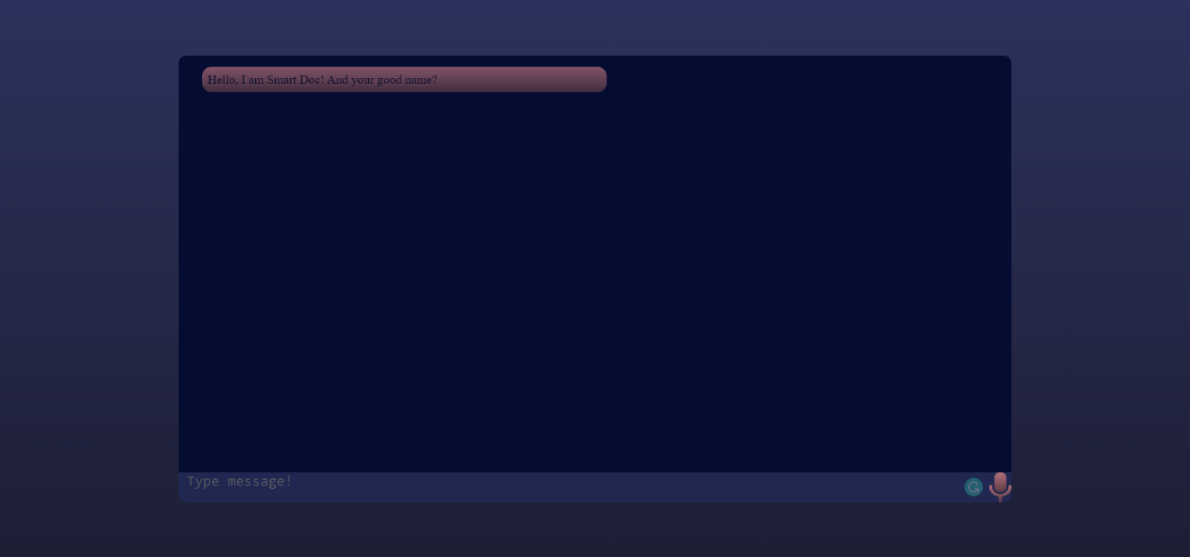

Fig 3.1 Smart Doc

35

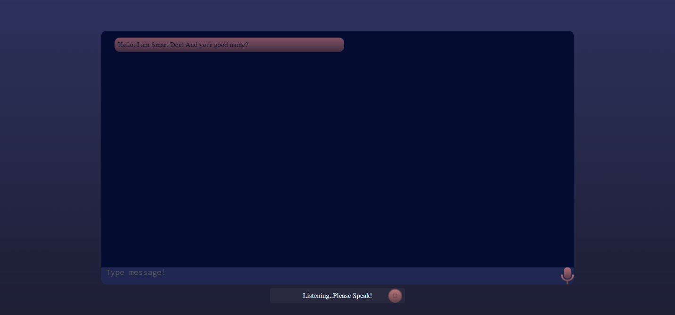

Fig 3.2 Mic Access

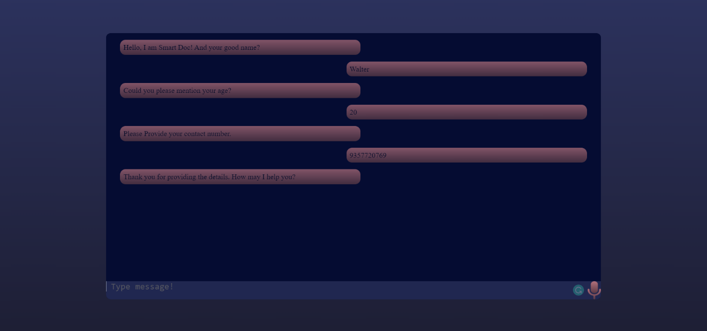

Fig 3.3 Getting User Details

36

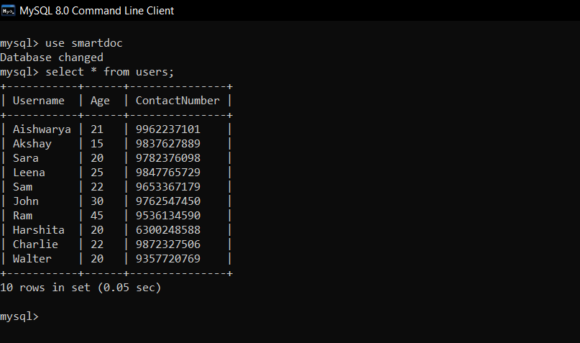

Fig 3.4 User Table

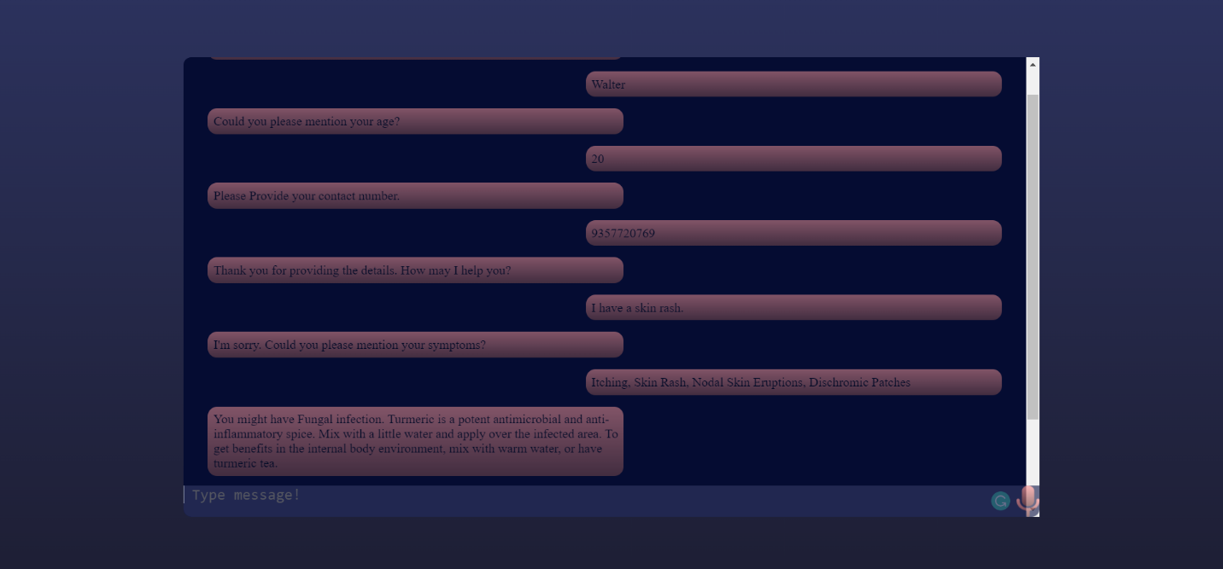

Fig 3.5 Disease Prediction and Treatment

37

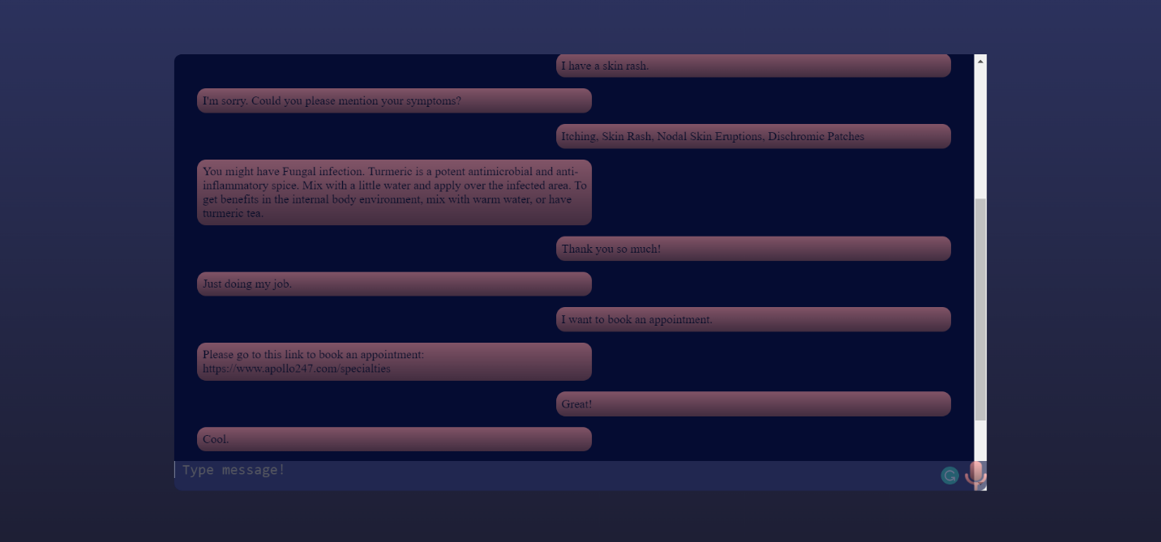

Fig 3.6 Schedule Appointment

38

**CHAPTER- 4**

**CONCLUSION**

* 1. **CONCLUSION**

A Chatbot is never tired; it is never short of patience for a patient! A Chatbot hears your patients, analyzes their response and then carefully delivers a tailor made reply. Patient satisfaction in these type of encounters is maximum as they get what they want without any diversions or delays. This chatbot will help you get instant resolutions with hands on experience for the stated issues. It makes your work easy and produce adequate results as they are automated.

* 1. **FUTURE SCOPE**

Since the system aims at improving medical assistance, subsequent improvements to the dataset and to the system are required which is facilitated by the thorough evaluation in order to enable scalable implementation. Thus enabling evaluation and analysis by various domain experts to iteratively improve the dataset as well as the system. By adding new functionalities, such as the management of medical records, and the automatic suggestion of food and physical activity to perform based on the user’s health conditions will enhance the scope of the project in future.

39

**CHAPTER- 5**

**REFERENCES**

[1] Nikita Vijay Shinde, Aniket Akhade, Pranali Bagad, Harshit Bhavsar, Dr. S.K.Wagh, Prof. Amol Kamble, “Healthcare Chatbot System using Artificial Intelligence” 2021, IEEE.

[2] Resmi Ramakrishnan, Pillai Amal Manoj, Krishna Sreejish, Neetisha Uniyal, “Meddoc- The AI Doctor”, 2021, IRJET.

[3] [Amela Softić](https://ieeexplore.ieee.org/author/37088839566), [Jasmina Baraković Husić](https://ieeexplore.ieee.org/author/37085998531), [Aida Softić](https://ieeexplore.ieee.org/author/37088839565), [Sabina Baraković](https://ieeexplore.ieee.org/author/37085919214), Health Chatbot: Design, Implementation, Acceptance and Usage Motivation”, 2021, IEEE.

[4] Muse Mohamud Mohamed, Professor Wang Zhuopeng, “Artificial Intelligence Health Care Chatbot System”, 2020, IJARCCE.

[5] [Sagar Badlani](https://ieeexplore.ieee.org/author/37088849350), [Tanvi Aditya](https://ieeexplore.ieee.org/author/37088891476), [Meet Dave](https://ieeexplore.ieee.org/author/37088892259), [Sheetal Chaudhari](https://ieeexplore.ieee.org/author/37992226200), “Multilingual Healthcare Chatbot Using Machine Learning”,2021, IEEE.

[6] [Prakhar Srivastava](https://ieeexplore.ieee.org/author/37088395254), [Nishant Singh](https://ieeexplore.ieee.org/author/37088397033), “Automatized Medical Chatbot (Medibot)”, 2020, IEEE.

[7] Ms Menal Dahiya, “A Tool of Conversation: Chatbot”, 2017, IJCSE.

[8] Mrs. Rashmi Dharwadkar, Dr.Mrs. Neeta A. Deshpande, “A Medical ChatBot”, 2018, IJCTT.

[9] [Roop Chandrika Mallela](https://ieeexplore.ieee.org/author/37088892041), [Reddy Lakshmi Bhavani](https://ieeexplore.ieee.org/author/37088894546), [B. Ankayarkanni](https://ieeexplore.ieee.org/author/37085871588), “Disease Prediction Using Machine Learning Techniques”, 2021, IEEE.

40

[10] [Marco Polignano](https://ieeexplore.ieee.org/author/37088421682), [Fedelucio Narducci](https://ieeexplore.ieee.org/author/37671385400), [Andrea Iovine](https://ieeexplore.ieee.org/author/37088422873), [Cataldo Musto](https://ieeexplore.ieee.org/author/37671383500), [Marco De Gemmis](https://ieeexplore.ieee.org/author/37671380900), [Giovanni Semeraro](https://ieeexplore.ieee.org/author/37421229100), “HealthAssistantBot: A Personal Health Assistant for the Italian Language, 2020, IEEE.

[11] [Abdullah Faiz Ur Rahman Khilji](https://ieeexplore.ieee.org/author/37088499749), [Sahinur Rahman Laskar](https://ieeexplore.ieee.org/author/37088373605), [Partha Pakray](https://ieeexplore.ieee.org/author/37595270500), [Rabiah Abdul Kadir](https://ieeexplore.ieee.org/author/37393865100), [Maya Silvi Lydia](https://ieeexplore.ieee.org/author/37086288352), [Sivaji Bandyopadhyay](https://ieeexplore.ieee.org/author/37287104600), “HealFavor: Dataset and A Prototype System for Healthcare ChatBot”, 2020, IEEE.

[12] [Gauri Tawde](https://ieeexplore.ieee.org/author/37087059974), [Yash Choksi](https://ieeexplore.ieee.org/author/37087056799), [Roshan Singh](https://ieeexplore.ieee.org/author/37087061670), [Krishna Samdani](https://ieeexplore.ieee.org/author/37086276030), “A Study on Machine Learning enabled IoT devices for Medical Assistance”, 2019, IEEE.

[13] Dr. V Sheeja Kumari, Beksy S George, Nisha Varghese, Sherin Mary Mathew, Telma Elza Ninan, “Humicare- A Chatbot For Healthcare System”, 2021, IRJET.

[14] Hiba Hussain, Komal Aswani, Mahima Gupta, Dr. G.T.Thampi, “Implementation of Disease Prediction Chatbot and Report Analyzer using the Concepts of NLP, Machine Learning and OCR”, 2020, IRJET.

[15] Shadab Adam Pattekari, Asma Parveen, “Prediction System For Heart Disease Using Naïve Bayes”, 2012, IJCMS.

[16] [Ruyi Wang](https://ieeexplore.ieee.org/author/37088863175), [Jiankun Wang](https://ieeexplore.ieee.org/author/37088864100), [Yuan Liao](https://ieeexplore.ieee.org/author/37088861061), [Jinyu Wang](https://ieeexplore.ieee.org/author/37088864104), “Supervised Machine Learning Chatbots for Perinatal Mental Healthcare”, 2020, IEEE.

41

**UDEMY COURSE COMPLETION CERTIFICATE**

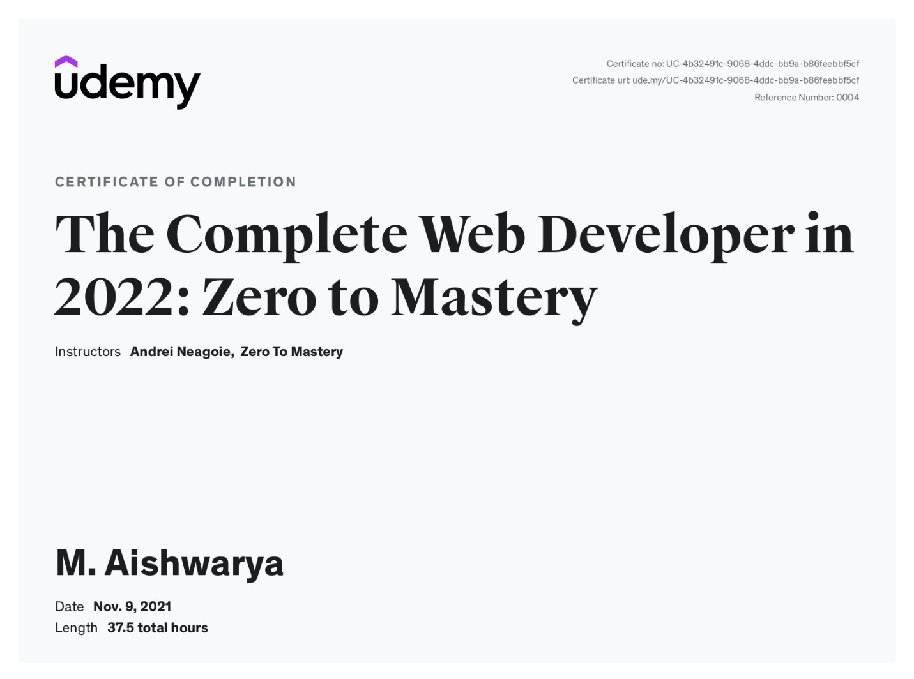

42